

**Semester VI (CS, SE) Section (A, B) (Spring 2022) Course Instructor(s): Riaz Ali Soomro**

**CSC-325: Web Engineering - Lab**

**Lab 01: Introduction to HTML**

# Objective(s):

1. To create HTML pages using basic HTML tags.
2. To create HTML tables and Forms.
3. To understand other basics

**Lab Task(s):**

**Exercises**

1. Create an HTML page using ordered and nested ordered lists.

**Code:**

<html>

<head>

<title>This page for List</title>

</head>

<body>

<center>

<h5>Web Site outline</h5>

</center>

<ol>

<li>Home page</li>

<li>Link page</li>

<ol type='i'>

<li>links to search Engines</li>

<li>inks to information site</li>

<ol type ='A'>

<li>News Site</li>

<ol type ='I'>

<li>TV based</li>

<ol type ='a'>

<li>CNN</li>

<li>Headline</li>

</ol>

</ol>

<li>Stock Site</li>

</ol>

<li>inks to fun site</li>

</ol>

<li>Contact page</li>

</ol>

</body>

</html>

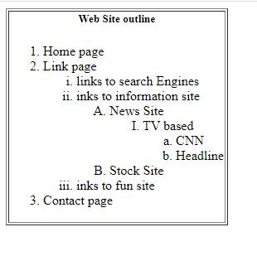

1. Create a login form

**Code:**

<html>

<head>

<title>Login form</title>

</head>

<body>

<table>

<img src="icon.png" width="10%" height="15%">

</tr>

<br><br>

<tr>

<form>

<label for="username">Username:</label>

<input type="text" id="uname" name="uname" placeholder="Username"><br><br>

<label for="pwd">Password:</label>

<input type="password" id="pwd" name="pwd" placeholder="Password">

</form>

</tr>

<br><br>

<tr>

<button type="button" class="loginbtn">Login</button>

<button type="button" class="cancelbtn">Cancel</button>

</tr>

<br><br>

<tr>

<input type="checkbox" id="Remember" name="rem" value="Remember">

<label for="username">Remember me</label>

</tr>

<br>

<tr>

<p>Forget

<a href="Password">Password?</p></a>

</tr>

</table>

</body>

</html>

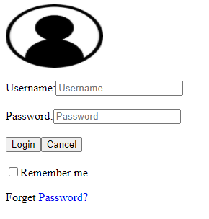

1. Create following tables using rowspan & colspan.

**Code:**

<html>

<head>

<title>This page for tabel</title>

</head>

<body>

<table border 2>

<tr>

<td rowspan=3>users Info</td>

<td>1</td>

<td>John carter</td>

<td>Johncarter@mail.com</td>

</tr>

<tr>

<td>2</td>

<td>peter parker</td>

<td>peterparker@mail.com</td>

</tr>

<tr>

<td>3</td>

<td>John Rambo</td>

<td>JohnRambo@mail.com</td>

</tr>

</table>

</body>

</html>

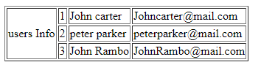

* 1. **Create following tables using rowspan & colspan.**

**CODE:**

<html>

<head>

<title>This page for tabel</title>

</head>

<body>

<table border 2>

<tr align="center">

<td colspan="4">users Info</td>

</tr>

<tr>

<td>1</td>

<td>John carter</td>

<td>Johncarter@mail.com</td>

</tr>

<tr>

<td>2</td>

<td>peter parker</td>

<td>peterparker@mail.com</td>

</tr>

<tr>

<td>3</td>

<td>John Rambo</td>

<td>JohnRambo@mail.com</td>

</tr>

</table>

</body>

</html>

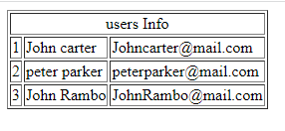

* 1. **Create following tables using rowspan & colspan.**

Code: <!DOCTYPE html>

<html>

<head>

<title> table </title>

</head>

<body>

<p>Furit juice Drinks and Meals</p>

<table border 2 >

<tr>

<td rowspan=2></td>

<td colspan=4>Fruit juice Drinks</td>

</tr>

<tr>

<td>Apple</td>

<td>Orange</td>

<td>ScrewDriver</td>

</tr>

<tr>

<td>BreakFast</td>

<td>0</td>

<td>1</td>

<td>0</td>

</tr>

<tr>

<td>Lunch</td>

<td>1</td>

<td>0</td>

<td>0</td>

</tr>

<tr>

<td>Dinner</td>

<td>0</td>

<td>0</td>

<td>1</td>

</tr>

</table>

</body>

</html>

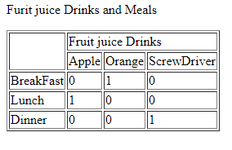

1. **Create webpage about a recipe. Your page should have a description of the recipe, an image showing its output, list of ingredients, and steps/instructions to be followed in sequence to prepare that recipe.**

**Code:**

<!DOCTYPE html>

<html>

<head>

<title>Recipe</title>

</head>

<body>

<h1>

Cajun Chicken

</h1>

<h3>This is a recipe that we have made in our Resturent for many years--everyone loves it.</h3>

<p>

Prep: 15 mins <br>

Cook: 15 mins <br>

Additional: 30mins<br>

Total: 1 hr<br>

Servings:10 <br>

Yield: 10 servings

</p>

<img src="pic.webp" height="250px" width="300px">

<h2>Ingredients</h2>

<ul>

<li>2 cups vegetable oil</li>

<li>2 tablespoons Cajun seasoning</li>

<li>2 cloves garlic, minced</li>

<li>2 tablespoons dried Italian-style seasoning</li>

<li>garlic powder to taste</li>

<li>2 tablespoons lemon pepper</li>

<li>10 skinless, boneless chicken breast halves - pounded to 1/2 inch thickness</li>

</ul>

<h3>DirectionsInstructions Checklist</h3>

<h4>Step 1</h4>

<p>In a large shallow dish, mix the oil, Cajun seasoning, Italian seasoning, garlic powder, and lemon pepper. Place the chicken in the dish, and turn to coat with the mixture. Cover, and refrigerate for 1/2 hour.

</p>

<h4>Step 2</h4>

<p>Preheat the grill for high heat.</p>

<h4>Step 3</h4>

<p>Lightly oil the grill grate. Drain chicken, and discard marinade. Place chicken on hot grill and cook for 6 to 8 minutes on each side, or until juices run clear.</p>

<h3>Editor's Note:</h3>

<p>

The nutrition data for this recipe includes information for the full amount of the marinade ingredients. Depending on marinating time, ingredients, cook time, etc., the actual amount of the marinade consumed will vary.

</p>

<h3>Nutrition Facts</h3>

<p>Per Serving: 536 calories; protein 24.8g; carbohydrates 1.8g; fat 47.8g; cholesterol 67.2mg; sodium 620.2mg. Full Nutrition</p>

</body>

</html>

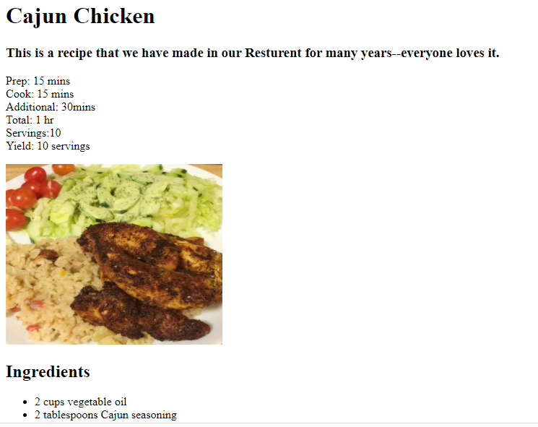

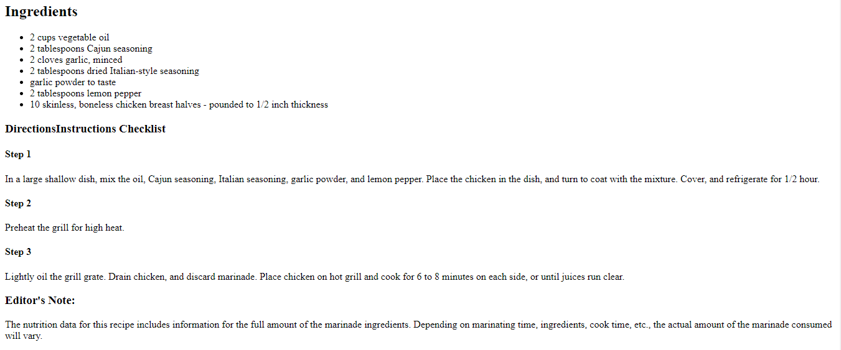

1. **Create the following form using only HTML.**

**Code:**

<html>

<head>

<title> Popcorn Sales Form </title>

</head>

<body>

<h2> Welcome to Millennium Gymnastics Booster Club Popcorn Sales </h2>

<form>

<table>

<tr>

<td><label for="buyersName">Buyer's Name:</label></td>

<td>

<input type="text" id="buyersName" name="name" size="30" />

</td>

</tr>

<tr>

<td><label for="streetAddress">Street Address:</label></td>

<td>

<input type="text" id="streetAddress" name="street" size="30"/>

</td>

</tr>

<tr>

<td><label for="cityStateZip">City State Zip:</label></td>

<td>

<input type="text" id="cityStateZip" name="city" size="30"/>

</td>

</tr>

</table>

<table>

<tr>

<th> Product Name </th>

<th> Price </th>

<th> Quantity </th>

</tr>

<tr>

<th><label for="unpopped">Unpopped Popcorn (1 lb)</label></th>

<td> $3.00 </td>

<td>

<input type="text" id="unpopped" name="unpop" size="2" />

</td>

</tr>

<tr>

<th><label for="caramel">Caramel Popcorn (1 lb)</label></th>

<td> $3.50 </td>

<td>

<input type="text" id="caramel" name="caramel" size="2" />

</td>

</tr>

<tr>

<th><label for="caramelNut">Caramel Nut Popcorn (1 lb)</label></th>

<td> $4.50 </td>

<td>

<input type="text" id="caramelNut" name="caramelnut" size="2" />

</td>

</tr>

<tr>

<th><label for="toffeyNut">Toffey Nut Popcorn (1 lb)</label></th>

<td> $5.00 </td>

<td>

<input type="text" id="toffeyNut" name="toffeynut" size="2" />

</td>

</tr>

</table>

<h3> Payment Method: </h3>

<p>

<input type="radio" name="payment" value="visa" checked />

Visa

<br>

<input type="radio" name="payment"

value="mc" />

Master Card

<br>

<input type="radio" name=

"payment" value="discover" />

Discover

<br>

<input type=

"radio" name="payment" value="cheque" />

Cheque

<br />

</p>

<p>

<input type="submit" value="Submit Order" />

<input type=

"reset" value="Clear Order Form" />

</p>

</form>

</body>

</html>

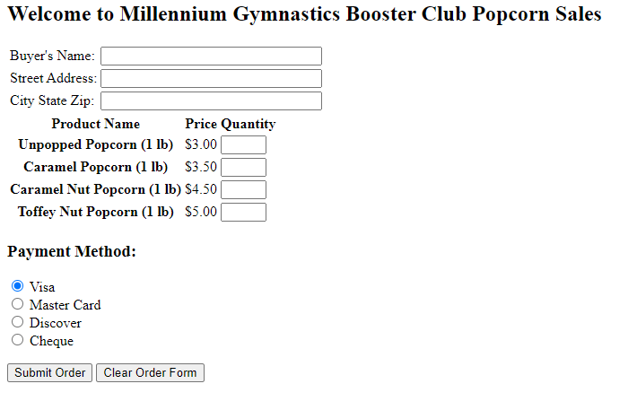

1. Create the following timetable using HTML table tags.

# Note:

* 1. Ignore the SIBAU Logo (i.e., do NOT insert image). Just focus on the textual data
  2. Inside the cells that contain subject names, only write/put subject names. Do NOT write batch name or section or location/room number (just subject name is enough).
  3. Also, do NOT worry about the vertical text mentioning **Lunch Break**. You can just write horizontal text there.

**CODE:**

<!DOCTYPE html>

<html>

<head>

<title></title>

</head>

<body>

<table border="1" align="center">

<h1 align="center">Teacher Riaz Soomro</h1>

<tr><th rowspan="1"></th>

<th>1<br>09:00<br>10:00AM</th>

<th>2<br>10:00<br>11:00AM</th>

<th>Break<br>11:00<br>11:30AM</th>

<th>3<br>11:30<br>12:30PM</th>

<th>4<br>12:30<br>01:30PM</th>

<th>lunch break<br>1:30<br>02:00PM</th>

<th>5<br>02:10<br>03:00PM</th>

<th>6<br>03:00<br>04:00PM</th>

<th>7<br>4:10<br>05:25PM</th>

<th>8<br>05:30<br>06:50PM</th>

<th>9<br>06:50<br>07:50PM</th>

<th>10<br>07:50<br>08:50PM</th>

</tr>

<tr>

<th>Mo</th>

<td></td>

<td></td>

<td rowspan="7"></td>

<td></td>

<td></td>

<td rowspan="7"></td>

<td></td>

<td></td>

<td colspan=2"><h6>BBA-IV(C&D)</h6><h3>Introduction to programming</h3><h6>R-205, B-II D</h6></td>

<td></td>

<td></td>

</tr>

<tr>

<th>Tu</th>

<td></td>

<td></td>

<td></td>

<td></td>

<td></td>

<td></td>

<td colspan="2"><h6>BBA-IV(C&D)</h6><h3>Introduction to programming</h3><h6>R-17, B-I C</h6></td>

<td></td>

<td></td>

</tr>

<tr>

<th>We</th>

<td colspan="2"><h6>BS-VI(CS)-A/BE-VII(CS)</h6><h3>Web Engineering-Lab</h3><h6>R-1058, B-II </h6></td>

<td><h6>BS-VI(CS)-A/BE-VII(CS)</h6><h3>Web Engineering-Lab</h3><h6>R-1058, B-II </h6></td>

<td ></td>

<td></td>

<td></td>

<td></td>

<td></td>

<td></td>

<td></td>

</tr>

<tr>

<th>Th</th>

<td></td>

<td></td>

<td></td>

<td></td>

<td></td>

<td></td>

<td colspan="2"><h6>BBA-IV(C&D)</h6><h3>Introduction to programming</h3><h6>R-17, B-I D</h6></td>

<td></td>

<td></td>

</tr>

<tr>

<th>Fr</th>

<td></td>

<td></td>

<td></td>

<td></td>

<td></td>

<td></td>

<td></td>

<td colspan="2"><h6>BBA-IV(C&D)</h6><h3>Introduction to programming</h3><h6>R-17, B-I C</h6></td>

<td></td>

</tr>

<tr>

<th>Sa</th>

<td></td>

<td></td>

<td colspan="2"><h6>BS-VI(CS)-A/BE-VII(CS)</h6><h3>Web Engineering-Lab</h3><h6>R-1058, B-II </h6></td>

<td><h6>BS-VI(CS)-A/BE-VII(CS)</h6><h3>Web Engineering-Lab</h3><h6>R-1058, B-II </h6></td>

<td></td>

<td></td>

<td></td>

<td></td>

<td></td>

</tr>

</table>

</body>

</html>

